**THE UNIVERSITY OF AZAD JAMMU AND KASHMIR**



__________________________________________

|  |  |
| --- | --- |
| COURSE TITLE | CA&LD |
| COURSE CODE | CS-1205 |
| TITLE | Logic Gates |
| STUDENT NAME | Tayyab Hanif |
| STUDENT ROLL NUMBER | 2024-SE-11 |
| INSTRUCTOR NAME | Engr. Sidra Rafique |
| Lab No: | 03 |

**NAND Gate:**

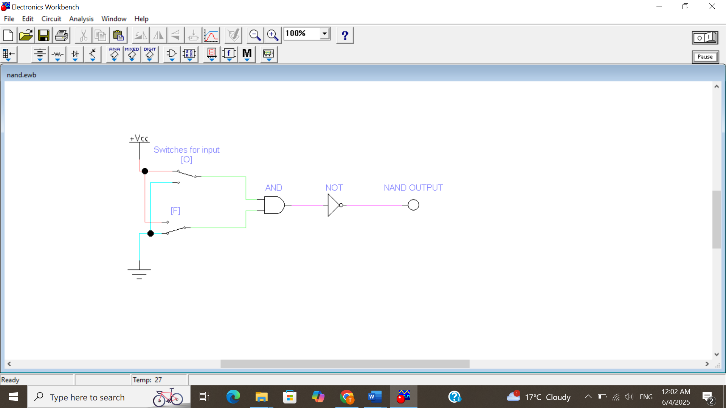

**NAND IC:**

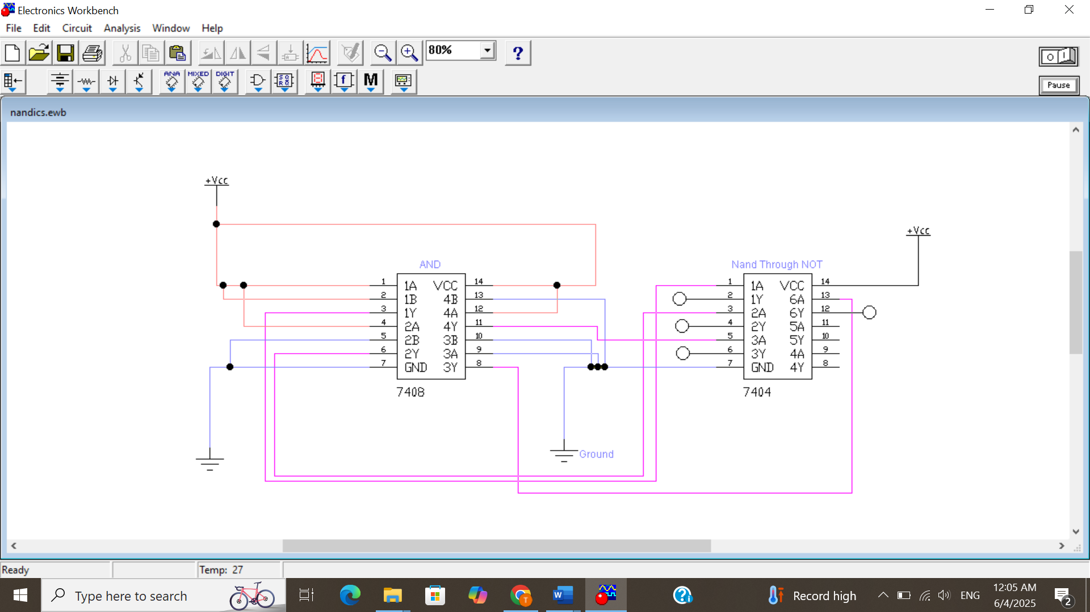

**NAND truth table:**

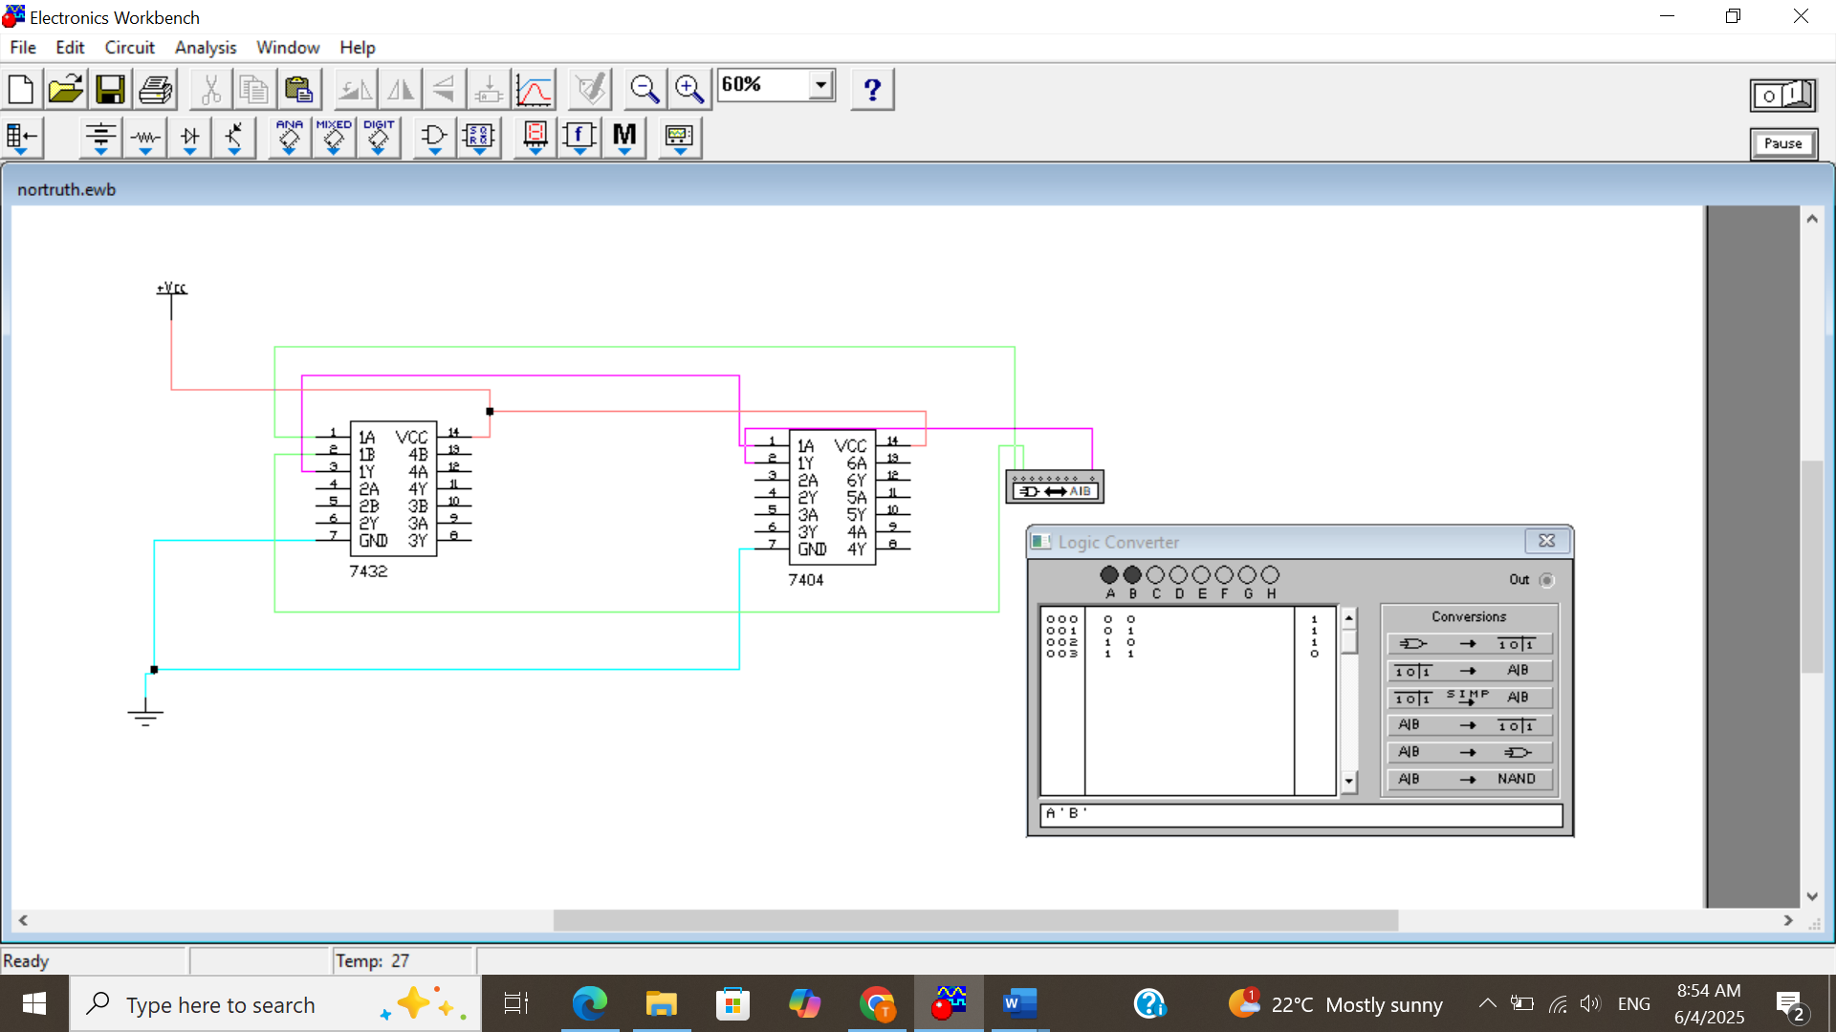

**Implementation**

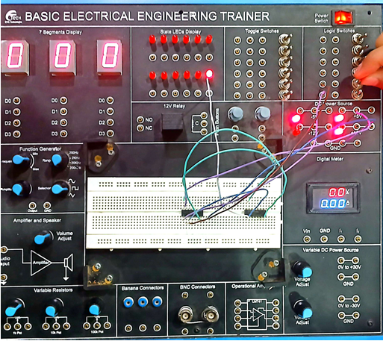

**NOR IC:**

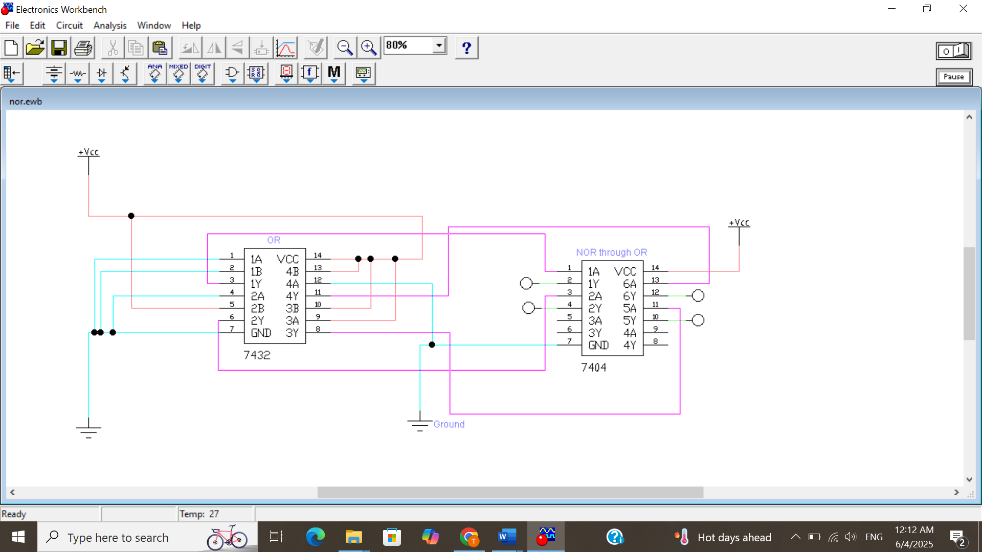

**NOR truth table:**

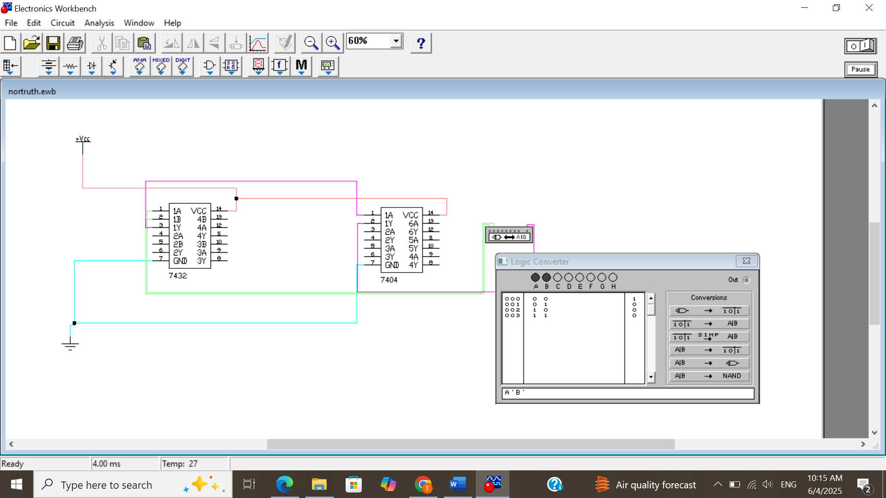

**Implementation**

